# UNIT – 4

Throughput : A measure of how many units of information a system can process in a given amount of time

LTE stands for Long Term Evolution and it was started as a project in 2004 by telecommunication body known as the Third Generation Partnership Project (3GPP). LTE evolved from an earlier 3GPP system known as the Universal Mobile Telecommunication System (UMTS), which in turn evolved from the Global System for Mobile Communications (GSM).

Evolution => GSM => UMTS => LTE

* LTE is the successor technology not only of UMTS but also of CDMA 2000.
* LTE is important because it will bring up to 50 times performance improvement and much better spectral efficiency to cellular networks.
* LTE introduced to get higher data rates, 300Mbps peak downlink and 75 Mbps peak uplink. In a 20MHz carrier, data rates beyond 300Mbps can be achieved under very good signal conditions.
* LTE is an ideal technology to support high date rates for the services such as voice over IP (VOIP), streaming multimedia, videoconferencing or even a high-speed cellular modem.
* LTE uses both Time Division Duplex (TDD) and Frequency Division Duplex (FDD) mode. In FDD uplink and downlink transmission used different frequency, while in TDD both uplink and downlink use the same carrier and are separated in Time.

Advantages of LTE

* **High throughput:** High data rates can be achieved in both downlink as well as uplink. This causes high throughput.
* **Low latency:** Time required to connect to the network is in range of a few hundred milliseconds and power saving states can now be entered and exited very quickly.
* **FDD and TDD in the same platform:** Frequency Division Duplex (FDD) and Time Division Duplex (TDD), both schemes can be used on same platform.
* **Superior end-user experience:** Optimized signaling for connection establishment and other air interface and mobility management procedures have further improved the user experience. Reduced latency (to 10 ms) for better user experience.
* **Seamless Connection:** LTE will also support seamless connection to existing networks such as GSM, CDMA and WCDMA.
* **Plug and play:** The user does not have to manually install drivers for the device. Instead system automatically recognizes the device, loads new drivers for the hardware if needed, and begins to work with the newly connected device.
* **Simple architecture:** Because of Simple architecture low operating expenditure (OPEX).

Seamless Connection : Smooth Connection

Time duration for one frame (One radio frame, One system frame) is 10 ms. This means that we have 100 radio frame per second.

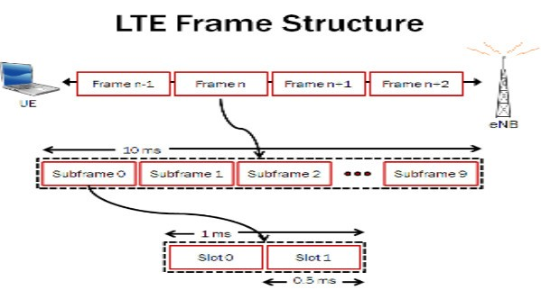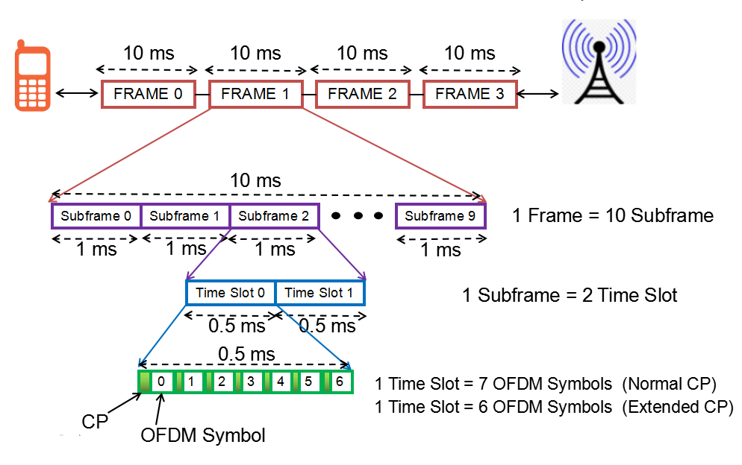

Let’s look at the frame structure:

* Some of high level description you can get from this figure would be
* Number of subframe in one frame is 10
* Number of slots in one subframe is 2. This means that we have 20 slots within one frame.
* And one slot is made up of 7 small blocks called

‘symbol’.

The frame structures for LTE differ between the Time Division Duplex, TDD and the Frequency Division Duplex, FDD modes as there are different requirements on segregating the transmitted data

There are two types of LTE frame structure:

1. Type 1: used for the LTE FDD mode systems.
2. Type 2: used for the LTE TDD systems. Type 1: FDD Frame Structure

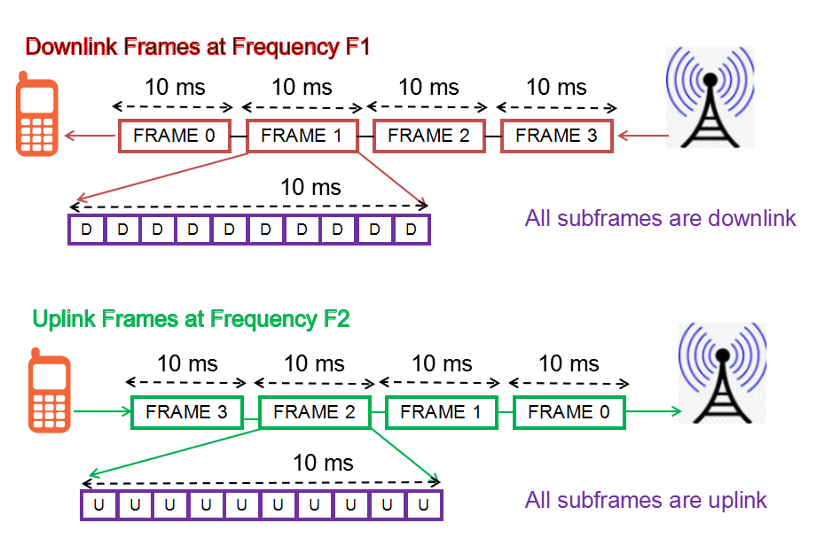

As LTE FDD is full duplex system, means both the downlink and uplink transmission happens at the

same time at different frequencies.

Type 2: TDD Frame Structure

In TDD, the transmission is divided into time domain, means at one moment of time either downlink subframe is transmitted or uplink.

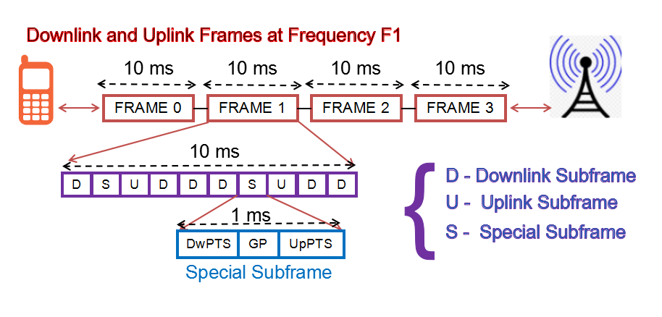

As one can see in above image, one frame is divided into 10 subframes (1ms each), and that subframe can be either downlink, uplink or special subframe.

**Architecture of LTE**

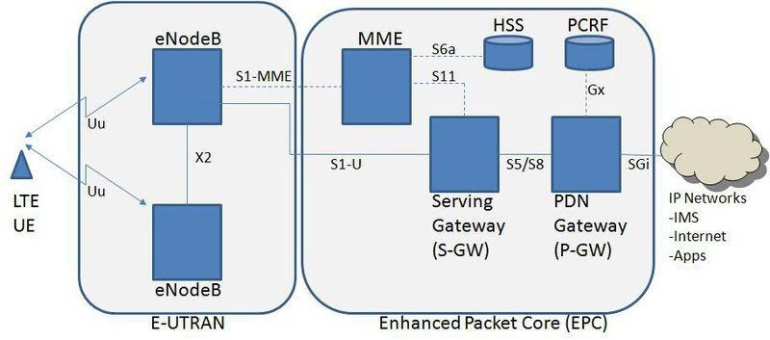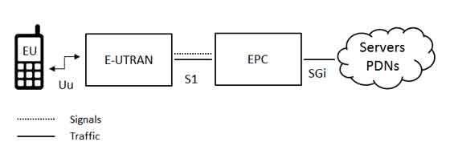

The high-level network architecture of LTE is comprised of following three main components:

•

•

•

The User Equipment (UE).

The Evolved UMTS Terrestrial Radio Access Network (E-UTRAN).

The Evolved Packet Core (EPC).

The evolved packet core communicates with packet data networks in the outside world such as the

internet, private corporate networks or the IP multimedia subsystem. The interfaces between the different parts of the system are denoted Uu, S1 and SGi as shown below:

The User Equipment (UE)

The internal architecture of the user equipment for LTE is identical to the one used by UMTS and GSM which is actually a Mobile Equipment (ME). The mobile equipment comprised of the following important modules:

* **Mobile Termination (MT)** : This handles all the communication functions.
* **Terminal Equipment (TE)** : This terminates the data streams.
* **Universal Integrated Circuit Card (UICC)** : This is also known as the SIM card for LTE equipments. It runs an application known as the Universal Subscriber Identity Module (USIM).

A **USIM** stores user-specific data very similar to 3G SIM card. This keeps information about the user's phone number, home network identity and security keys etc.

The E-UTRAN (The access network)

The architecture of evolved UMTS Terrestrial Radio Access Network (E-UTRAN) has been illustrated below.

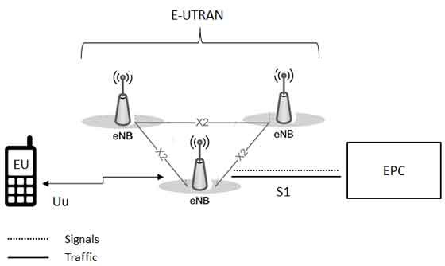

The E-UTRAN handles the radio communications between the mobile and the evolved packet core and just has one component, the evolved base stations, called **eNodeB** or **eNB**. Each eNB is a base station that controls the mobiles in one or more cells. The base station that is communicating with a mobile is known as its serving eNB.

LTE Mobile communicates with just one base station and one cell at a time and there are following two main functions supported by eNB:

* The eBN sends and receives radio transmissions to all the mobiles using the analogue and digital signal processing functions of the LTE air interface.
* The eNB controls the low-level operation of all its mobiles, by sending them signalling messages such as handover commands.

Each eBN connects with the EPC by means of the S1 interface and it can also be connected to nearby base stations by the X2 interface, which is mainly used for signalling and packet forwarding during handover.

A home eNB (HeNB) is a base station that has been purchased by a user to provide femtocell coverage within the home. A home eNB belongs to a closed subscriber group (CSG) and can only be accessed by mobiles with a USIM that also belongs to the closed subscriber group.

The Evolved Packet Core (EPC) (The core network)

The architecture of Evolved Packet Core (EPC) has been illustrated below. There are few more components which have not been shown in the diagram to keep it simple. These components are like the Earthquake and Tsunami Warning System (ETWS), the Equipment Identity Register (EIR) and Policy Control and Charging Rules Function (PCRF).

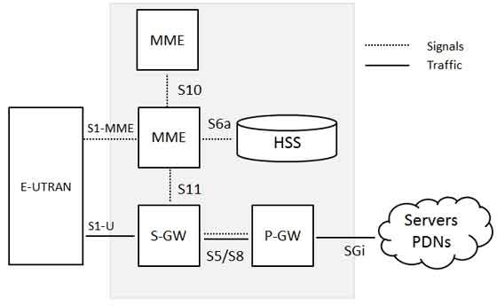

Below is a brief description of each of the components shown in the above architecture:

PDN-Gateway

Serving Gateway

* The Home Subscriber Server (HSS) component has been carried forward from UMTS and GSM and is a central database that contains information about all the network operator's subscribers.
* The Packet Data Network (PDN) Gateway (P-GW) communicates with the outside world ie. packet data networks PDN, using SGi interface. Each packet data network is identified by an access point name (APN). The PDN gateway has the same role as the GPRS support node (GGSN) and the serving GPRS support node (SGSN) with UMTS and GSM.
* The serving gateway (S-GW) acts as a router, and forwards data between the base station and the PDN gateway.
* The mobility management entity (MME) controls the high-level operation of the mobile by means of signalling messages and Home Subscriber Server (HSS).
* The Policy Control and Charging Rules Function (PCRF) is a component which is not shown in the above diagram but it is responsible for policy control decision-making, as well as for controlling the flow-based charging functionalities in the Policy Control Enforcement Function (PCEF), which resides in the P-GW.

The interface between the serving and PDN gateways is known as S5/S8. This has two slightly different implementations, namely S5 if the two devices are in the same network, and S8 if they are

.

in different networks

**VOLTE**

stands for Voice over Long Term Evolution (LTE). It is a standards-based technology that is developed to support voice calls over an LTE network. It delivers high-quality voice communication, video calls, messaging services, and data over 4G wireless network or 4G Long Term Evolution (LTE) networks for mobile and portable devices.

It defines the standards and procedures for delivering voice communication and data over 4G LTE networks. When you make a call using VoLTE supported phone, the voice goes over the carrier's high-speed data network instead of its voice network. Thus, it offers superior call quality, faster call connectivity, and ability to use voice and high-speed data at the same time. However, you need to use a phone that supports VolTE, in an area with 4G LTE service, and the person on the other end must also have the same facilities.

How VoLTE Works?

In VoLTE the call is carried over the IP network provided by the 4G network. It uses your 4G data connectivity to send data packets for voice calls, e.g., when you make calls using the internet like whatsup call, skype call, etc.

VoLTE allows carrying voice traffic using IP packets over the IP network (IP to IP based network). It carries your call as a stream of IP packets over data connections. So, it primarily works on IP-based networks and only supports packet switching.

Benefits of VoLTE:

* It enables you to use voice and data at the same time.
* It enables high definition (HD) voice calling, a significant improvement over traditional calls made via cellular networks.
* It connects calls easily and much faster than traditional GSM or CDMA.
* It offers more efficient use of spectrum than the traditional 2G or 3G technology.
* It increases battery life as it uses shorter discontinuous reception (DRx) which improves device power efficiency.

### Support for VoLTE

Read only highlighted lines

Most 4G wireless networks use LTE technology and thus support VoLTE. According to a January 2023 report from Global Mobile Suppliers Association, 292 network operators worldwide have invested in VoLTE technology, and 258 of them have launched VoLTE networks.

VoLTE is important for network operators, vendors, original equipment manufacturers and consumers. Since LTE is a data-only networking technology, VoLTE provides higher quality calls, better service, and the ability to use voice and data simultaneously. Most cellular devices have VoLTE capabilities, including any iPhone after the iPhone 6, all Google Pixel models and Samsung Galaxy models after 2015. Users typically have the option to toggle VoLTE on and off through the device settings. To make a VoLTE call, both devices involved in the communication must be compatible with VoLTE, be located in a supported area and have VoLTE capabilities enabled.

### How does VoLTE work?

VoLTE is based on the This enables the service to deliver

IP Multimedia Subsystem framework.

multimedia as data flows using a common IP interface that can use but doesn't depend on a legacy circuit-switched voice network.

For example, a user might initiate a call using the LTE network. If they wander outside an LTE coverage area, the call will go back to the legacy network. This functionality is known as Single Radio Voice Call Continuity, where the LTE network simultaneously maintains two connections until the LTE signal disconnects.



Additionally, the recommended speech codec for VoLTE is adaptive multi-rate wideband, or HD

voice. HD voice increases the audio frequency range for voice calls and raises sound quality.

# 5G Network

Routing Control : Data ko route karta hai

Resiliency : Network me agar koi dikkat aati hai to SCP use handle karta hai aur network ko smoothly chalata hai

Observability : SCP network ko closely observe karta hai

A: 5G is the 5th generation mobile network. It is a new global wireless standard after 1G, 2G, 3G, and 4G networks. 5G enables a new kind of network that is designed to connect virtually everyone and everything together including machines, objects, and devices.

5G wireless technology is meant to deliver higher multi-Gbps peak data speeds, ultra low latency, more reliability, massive network capacity, increased availability, and a more uniform user experience to more users. Higher performance and improved efficiency empower new user experiences and connects new industries

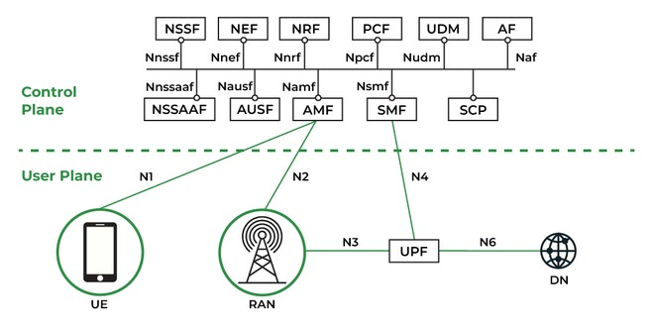

1. **NRF(Network Repository Function):** All of the 5G network functions (NFs) in the operator’s network are stored centrally in the Network Repository Function (NRF). The NRF provides a standards-based API that enables 5G NFs to register and find one another. A crucial element needed to execute the new service-based architecture (SBA) in the 5G core is NRF.
2. **PCF (Policy Control Function):** Policy Control Function makes it simple to develop and implement policies in a 5G network. PCF will help you monetize and reap the rewards of 5G because it was created and designed using cloud-native principles to address the demands of 5G services.
3. **BSF (Binding Support Function):** The Session Binding Function on the Diameter Routing Agent (DRA) used in 4G is comparable to the 5G Binding Support Function (BSF). When numerous Policy Control Function (PCF) systems are installed in the network, it becomes a necessary necessity.
4. **SCP (Service Communication Proxy):** By granting routing control, resiliency, and observability to the core network, Service Communication Proxy (SCP) enable operators to securely and effectively operate their 5G network. To address many of the issues brought on by the new service-based architecture (SBA) in the 5G core, SCP makes advantage of IT service mesh (ISTIO) and adds crucial capabilities to make it 5G-aware.
5. **NSSF (Network Slicing Selection Function):** In the 5G environment, where a variety of services are offered, the NSSF (Network Slicing Selection Function) system is a solution to choose the best network slice available for the service requested by the user.
6. **UDM (Unified Data Management) & UDR (User Data Repository):** UDM is cloud-native and created for 5G, similar to Home Subscriber Server (HSS) in LTE. It is in charge of creating the credentials needed for authentication, granting access depending on user subscription, and sending those credentials to the other network functions. It retrieves the credentials from the User Data Repository (UDR). Different key 5G features are supported by the UDM network function. In order to complete the authentication process, it creates authentication credentials. Based on user subscriptions, it approves network access and roaming.
7. **AUSF (Authentication Server Function):** 5G authentication and Key Agreement method 5G AKA are carried out via the authentication server function. In order to manage hidden or privacy-protected subscription identifiers, AUSF also provides additional functionality. During the registration process, AMF(Access and Mobility Function) is in charge of choosing the proper Authentication Server Function (AUSF).
8. **NWDAF (Network Data Analytics Function):** The 5G Network Data Analytics Function (NWDAF) is intended to improve the end-user experience by streamlining the production and consumption of key network data as well as generating insights and taking appropriate action. By expediting the production and consumption of core network data, creating insights, and acting on these insights, NWDAF is intended to address market fragmentation and proprietary solutions in the field of network analytics.

### 5G Core Network:

The 5G core network is the heart of 5G networking, it provides secure and reliable connectivity to the internet and access to all of the networking services. 5G core network has numerous essential functions for mobile networking like mobile management, subscriber data management, authorization, authentication policy management, etc.

The 5G core network is completely software-based and native to the cloud, it allows higher deployment agility and has flexibility and infrastructure which is similar to the cloud. Industry experts designed the 5G core to support the network functioning of the 5G network. Therefore, the 3GPP standard was developed which was named 5G core, it has the power to control and manage network functions.

**Difference between 4G and 5G are as follows:**

|  |  |
| --- | --- |
| **4G Technology** | **5G Technology** |
| It stands for Fourth Generation technology | It stands for Fifth Generation technology |
| The maximum upload rate of 4G technology is 500 Mbps | While the maximum upload rate of 5G technology is  1.25 Gbps |

|  |  |
| --- | --- |
| **4G Technology** | **5G Technology** |
| The maximum download rate of 4G technology is 1 Gbps | While the maximum download rate of 5G technology is 2.5 Gbps. |
| The latency of 4G technology is about 50 ms | While the latency of 5G technology is about 1 ms |
| 4G offers CDMA | While 5G offers OFDM, BDMA |
| 4G can’t differentiate between fixed and mobile devices | While 5G has the capability to differentiate between fixed and mobile devices. It uses cognitive radio techniques to identify each device and offer the most appropriate delivery channel. |
| 4G has the advantages of high speed handoffs, global mobility | While 5G has the advantages of extremely high speeds, low latency |
| 4G can be used for high speed applications, mobile TV, wearable devices | While 5G can be used for high resolution video streaming, remote control of vehicles, robots and medical procedures |
| It is slow and less efficient in comparison of 5G | It is fast and more efficient than 4G |

Compared to third generation mobile networking, 4G enabled previously impossible quality video streaming and calling on the go, meaning live TV is now routinely watched on the daily commute. More video streaming, however, has increased congestion in the network.



**How is 5G different from 4G?**

“4G is reaching the technical limits of how much data it can quickly transfer across blocks of spectrum,” explains Chris Mills head of industry analysis, at Tutela. “A major difference between 5G and 4G is this congestion will be eliminated.” This mean no more five bars of networking signal at rush hour but an inability to access a web browser.

But arguably, 5G’s biggest differentiator to 4G will be as a gateway for the Internet of Things- connected world at scale. Later iterations of 5G networking are expected to be revolutionary for

data-driven industries, smart cities and infrastructure management because it will be possible to have many more devices working, reliably, securely and uninterrupted in the same area.

Overall, due to the new technologies, spectrum and frequencies it uses, 5G has several benefits over 4G; higher speeds, less latency, capacity for a larger number of connected devices, less interference and better efficiency.

### How fast is 5G compared with 4G?

According to Vodafone, 5G promises device speeds around 10 times faster than 4G, meaning high- quality, ultra-high resolution 4K video calls - the standard used for commercial digital cinema - downloads will be delivered even quicker to smartphones and tablets. Data transfer of less than 20 milliseconds will be standard.

Mills warns, however, that much of what is published about the speed of 5G is hype - especially for consumers.

“Gigabytes speeds are useful for a handful of applications, such as live streaming an 8k VR headset over a 5G network, however, for the average user, there is not much need for that kind of speed on a mobile device,” he says, “Live streaming or downloading HD video is very achievable using a

4G network.”

**DISRUPTIVE TECHNOLOGIES FOR 5G**

The fifth generation (5G) cellular network is coming. What technologies will define it? Will 5G be just an evolution of 4G, or will emerging technologies cause a disruption requiring a wholesale rethinking of entrenched cellular principles as follows:

* Minor changes at both the node and archi-tectural levels (e.g., the introduction of codebooks and signaling support for a higher number of antennas). We refer to these as *evolutions* in the design.
* Disruptive changes in the design of a class of network nodes (e.g., the introduction of a new waveform). We refer to these as *component changes*.
* Disruptive changes in the system architecture (e.g., the introduction of new types of nodes or new functions in existing ones). We refer to these as *architectural changes*.
* Disruptive changes that have an impact at both the node and architecture levels. We refer to these as *radical changes*.

We focus on disruptive (component, architectural, or radical) technologies, driven by our belief that the extremely higher aggregate data rates and the much lower latencies required by 5G cannot be achieved with a mere evolution of the status quo. We believe that the following five potentially disruptive technologies could lead to both architectural and component design changes, as classified in Fig. 1.

1. **Device-centric architectures:** The base-station-centric architecture of cellular systems may change in 5G. It may be time to reconsider the concepts of uplink and downlink, as well as control and data channels, to better route information flows with different priorities and purposes toward different sets of nodes within the network. We present device-centric architectures.
2. **Millimeter wave (mmWave):** While spectrum has become scarce at microwave frequencies, it is plentiful in the mmWave realm. Such a spectrum “el Dorado” has led to an mmWave “gold rush” in which researchers with diverse backgrounds are studying different aspects of mmWave transmission. Although far from being fully understood, mmWave technologies have already been standardized for short-range services (IEEE 802.11ad) and deployed for niche applications such as small-cell backhaul. We discuss the potential of mmWave for broader application in 5G.

niche : specific

1. **Massive MIMO:** Massive multiple-input multiple-output (MIMO)1. proposes utilizing a very high number of antennas to multiplex messages for several devices on each time-frequency resource, focusing the radiated energy toward the intended directions while minimizing intra-and intercell interference. Massive MIMO may require major architectural changes, particularly in the design of macro base stations, and it may also lead to new types of deployments. We discuss massive MIMO.
2. **Smarter devices:** 2G-3G-4G cellular networks were built under the design premise of having complete control at the infrastructure side. We argue that 5G systems should drop this design assumption and exploit intelligence at the device side within different layers of the protocol stack, for example, by allowing device-to-device (D2D) connectivity or exploiting smart caching at the mobile side. While this design philosophy mainly requires a change at the node level (component change), it also has implications at the architectural level. We argue for smarter devices.
3. **Native support for machine-to-machine (M2M) communication:** A native 2. inclusion of M2M communication in 5G involves satisfying three fundamentally different requirements associated with different classes of low-data-rate services: support of a massive number of low-rate devices, sustaining a minimal data rate in virtually all circumstances, and very-low- latency data transfer. Addressing these requirements in 5G requires new methods and ideas at both the component and architectural levels, and such is the focus of a later section.

## What Is a 6G Network?

### A 6G network is defined as a cellular network that operates in untapped radio frequencies and uses cognitive technologies like AI to enable high-speed, low-latency communication at a pace multiple times faster than fifth-generation networks. 6G networks are currently under research and development, yet to be released.

6G is the sixth-generation mobile system standard currently being developed for wireless communications over cellular data networks in telecommunications. It is the successor, or the next bend in the road, after 5G and will likely be much faster.

The International Telecommunication Union (ITU) standardizes wireless generations every decade. Typically, they are denoted by a gap in the “air interface,” which signifies a shift in transmissions or coding. This is implemented so that older devices cannot be updated to the newer generation since doing so would generate a limitless quantity of “noise” and “spectrum pollution.”

Typically, subsequent generations (i.e., the next G) use much more sophisticated digital encoding that outdated computers cannot achieve. They depend on broader airwave bands that governments did not previously make accessible. Additionally, they have immensely complex antenna arrays that were previously impossible to construct. Today, we are in the fifth

generation. The first standard for 5G New Radio (NR) was developed in 2017 and is presently being implemented globally.

According to a report titled “*6G The Next Hyper-Connected Experience for All*,” the ITU will start work in 2021 to create a 6G mission statement. The standard will likely finish by 2028 when the first 6G devices are available. Around 2030, deployment will be close to ubiquitous.

How will 6G work?

The exact working of 6G is not yet known, as the specification is yet to be fully developed, finalized, and released by the ITU. However, depending on previous generations of cellular networks, one can expect several core functionalities. Primarily, 6G will operate by:

* **Making use of free spectrum**: A significant portion of 6G research focuses on transmitting data at ultra-high frequencies. Theoretically, 5G can support frequencies up to 100GHz, even though no frequency over 39GHz is currently utilized. For 6G, engineers are attempting to transfer data across waves in the hundreds of gigahertz (GHz) or terahertz (THz) ranges. These waves are minuscule and fragile, yet there remains a massive quantity of unused spectrum that could allow for astonishing data transfer speeds.
* **Improving the efficiency of the free spectrum**: Current wireless technologies permit transmission or reception on a specific frequency at the same time. For two-way communication, users may divide their streams as per frequency (Frequency Division Duplex or FDD) or by defining time periods (Time Division Duplex or TDD). 6G might boost the efficiency of current spectrum delivery using sophisticated mathematics to transmit and receive on the same frequency simultaneously.
* **Taking advantage of mesh networking**: Mesh networking has been a popular subject for decades, but 5G networks are still primarily based on a hub-and-spoke architecture. Therefore, end-user devices (phones) link to anchor nodes (cell towers), which connect to a backbone. 6G might use machines as amplifiers for one another’s data, allowing each device to expand coverage in addition to using it.
* **Integrating with the “new IP:**” A research paper from the Finnish 6G Flagship initiative at the University of Oulu suggests that 6G may use a new variant of the Internet Protocol (IP). It compares a current IP packet in IPv4 or IPv6 to regular snail mail, complete with a labeled envelope and text pages. The “new IP” packet would be comparable to a fast-tracked courier package with navigation and priority information conveyed by a courier service.

6G will rely on the selective use of different frequencies to evaluate absorption and adjust wavelengths appropriately. This technique will leverage the fact that atoms and molecules produce and absorb electromagnetic radiation at certain wavelengths, and the emissions and absorption frequencies of any particular material are identical.

When will 6G become available?

As mentioned earlier, The commercial debut of 6G internet is anticipated to go live around 2030-2035. In addition to the ITU, the Institute of Electrical and Electronics Engineers (IEEE), a non- profit society for technology standardization, ratifies this dateline in its peer-reviewed paper titled “*6G Architecture to Connect the Worlds*.”

The paper states, “2030 and beyond will offer a unique set of challenges and opportunities of global relevance and scale: We need an ambitious 6G vision for the communications architecture of the post-pandemic future to simultaneously enable growth, sustainability as well as full digital inclusion.”

While there have been some preliminary conversations to characterize the technology, 6G research and development (R&D) efforts began in earnest in 2020.

The 6G Flagship initiative combines studies on 6G technologies across Europe. Japan is committing $482 million to the expansion of 6G in the next few years. The country’s overarching objective is to showcase innovative wireless and mobile technologies by 2025. In Russia, the R&D institution NIIR and the Skolkovo Institute of Science and Technology produced a 2021 estimate predicting the availability of 6G networks by 2035.

American mobile providers are advancing their individual 6G innovation roadmaps. Importantly, AT&T, Verizon, and T-Mobile are spearheading the Next G Alliance, an industry initiative. In May 2021, the Next G Alliance initiated a technical work program to develop 6G technology.

Why is 6G necessary?

Given that the ink is yet to fully dry on 5G deployments (and even 4G penetration remains low in remote regions), one may ask why 6G efforts are necessary. Its primary focus is to support the 4th Industrial Revolution by building a bridge between human, machine, and environmental nodes.

In addition to surpassing 5G, 6G will have a range of unique features to establish next- generation wireless communication networks for linked devices by using machine learning (ML) and artificial intelligence (AI). This will also benefit emerging technologies like smart cities,

driverless cars, virtual reality, and augmented reality, in addition to smartphone and mobile network users.

It will combine and correlate different technologies, like deep learning with big data analytics. A substantial correlation between 6G and high-performance computing (HPC) has been observed. While some IoT and mobile data may be processed by edge computing resources, the bulk of it will require much more centralized HPC capacity — making 6G an essential component.

8 Unique Features of 6G

6G networks may coexist with 5G for a while and will be a significant improvement over previous generations in several ways. This is because 6G will offer the following differentiated features:

1. The use of new spectrum bands

Spectrum is an essential component of radio connections. Every new generation of mobile devices requires a pioneer spectrum to fully leverage the advantages of any further technological advancement. Reframing the current digital cellular spectrum from legacy technologies to the next generation will also be a part of this transformation.

For urban outdoor cells, the newest pioneer spectrum slabs for 6G are anticipated to be in the mid-bands 7-20 GHz. This would offer larger capacity via extreme Multiple Input Multiple Output (MIMO), low bands 460-694 MHz for extensive coverage, and sub-THz spectrums (between 90 GHz and 300 GHz) for peak data speeds surpassing 100 Gbps.

5G-Advanced will extend 5G beyond data transfer and significantly enhance localization accuracy to centimeter-level precision. Localization will be pushed to the next level by 6G’s use of a broad spectrum, including new spectral ranges of up to terahertz.

1. Very high data transfer speeds

5G is scheduled to offer a peak data throughput of 20 Gbps and a user-experienced data rate of 100 Mbps. However, 6G will deliver a maximum data rate of 1 Tbps. Similarly, it will raise the data rate experienced by the user to 1 Gbps. Therefore, the spectral efficiency of 6G will be nearly more than double that of 5G.

Higher spectral efficiency will offer many users instantaneous access to modern multimedia services. Network operators must redesign their current infrastructure frameworks to enable higher spectral efficiency.

1. Ultra-low latency network functions

The latency of 5G will be lowered to just one millisecond. Many real-time applications’ performance will be enhanced by this ultra-low latency. However, wireless communication technology of the sixth generation will decrease user-experienced latency to less than 0.1 milliseconds. Numerous delay-sensitive real-time applications will have better performance and functionality due to this drastic reduction in latency.

Additionally, decreased latency will allow emergency response, remote surgical procedures, and industrial automation. Furthermore, 6G will facilitate the seamless execution of delay-sensitive real-time applications by making the network 100 times more dependable than 5G networks.

1. Greater support for machine-to-machine (M2M) connections

While 5G addresses both human users and Internet of Things (IoT) use cases, 6G will focus more on M2M connectivity. Today’s 4G networks support around 100,000 devices per square kilometer. 5G is significantly more advanced, enabling the connectivity of one million devices per square kilometer. With the advent of 6G networks, the target of 10 million linked devices per square kilometer is within reach.

All 6G networks will include mobile edge computing, although it must be added to current 5G networks. By the time 6G networks are implemented, edge and core computing will be increasingly assimilated as elements of a unified communication and compute infrastructure framework.

1. A focus on energy efficiency

As previously discussed, 6G networks will require stronger radio frequencies to meet the requirement for greater bandwidth. However, one of the challenges is that the foundational (chip) technology cannot (yet) function energy-efficiently in these frequency ranges. Therefore, optimizing power consumption will be a key focus area for 6G developers. Currently, researchers intend to reduce the energy consumption per bit to lower than one nanojoule (10-9 joules), as per the peer- reviewed paper titled “*From 5G to 6G Technology: Meets Energy, Internet-of-Things and Machine Learning: A Survey*.”

1. Greater network reliability

The 5G-led Ultra-Reliable Low-Latency Communication (URLLC) service will be further developed and enhanced in 6G. Reliability might be enhanced through simultaneous transmission, numerous wireless hops, device-to-device connectivity, and AI/ML. Consequently, 6G will be better than 5G in terms of network penetration and stability. In addition, 6G will optimize M2M interactions by increasing network dependability by greater than a hundredfold and decreasing error rates by tenfold compared to previous generations.

1. The rise of new architectures

5G represents the first solution designed to replace wired connections in corporate and industrial settings. It is deploying services-led architecture in the core foundation and cloud-native deployments, which will be expanded to portions of the radio access network (RAN). It is also anticipated that 6G networks will be implemented in heterogeneous cloud settings, including a combination of private, public, and hybrid clouds with a suitable architecture to support this.

1. The use of AI and ML for optimal connectivity

5G will allow artificial intelligence (AI) and machine learning (ML) technologies to achieve their full potential. Eventually, AI/ML will be implemented in various network components, network levels, and network services. From refining beamforming in the radio tier to planning at the cell site with self-optimizing networks, AI/ML will assist in achieving superior efficiency at reduced computational complexity.

6G developers, such as Nokia Bell Labs, want to adopt a blank slate approach to AI/ML, allowing AI/ML to determine the optimal method of communication between two endpoints.

**Advantages of 6G Networks**

6G networks are anticipated to offer the following benefits:

1. Enforces security

Cyberattacks are increasingly focusing on networks of various types. The sheer unpredictability of these attacks necessitates the implementation of robust security solutions. 6G networks will have safeguards against threats like jamming. Privacy concerns must be addressed

when creating new mixed-reality environments that include digital representations of actual and virtual objects.

1. Supports personalization

OpenRAN is a fresh and evolving technology that 5G utilizes. However, OpenRAN will be a mature technology for 6G. The AI-powered RAN will allow operators of mobile networks to provide users with a bespoke network experience based on real-time user data gathered from multiple sources. The operators may further exploit real-time user data to provide superior services by personalizing quality of experience (QoE) and quality of service (QoS). The operators may customize several services using AI.

1. Extends the capabilities of 5G apps

This degree of bandwidth and responsiveness will enhance 5G application performance. It will also broaden the spectrum of capabilities to enable new and innovative wireless networking, cognition, monitoring, and imaging applications. Using orthogonal frequency-division multiple access (OFDMA), 6G access points will be able to serve several customers at the same time.

1. Drives the development of wireless sensing technologies

The sampling rate refers to the number of samples obtained from a continuous signal per second (or as per an equivalent time unit) to form a digital signal. 6G’s frequencies will allow for much faster sample rates than 5G. Additionally, they will provide dramatically increased throughput and data rates. Moreover, the utilization of sub-mm waves (wavelengths lower than 1 millimeter) and frequency selectivity is expected to accelerate the advancement of wireless sensing technologies.

The network will become a repository of situational data by collecting signals reflected from objects and detecting their type, shape, relative position, velocity, and possibly material qualities.

Such a sensing method may facilitate the creation of a “mirror” or digital counterpart of the actual environment. When combined with AI/ML, this information will provide fresh insights into the physical world, thereby rendering the network more intelligent.

1. Inspiring new technology innovations

6G will benefit society as a whole since new technological innovations will emerge to support it. This includes:

* **More advanced data centers**: 6G networks will generate significantly more data when compared to 5G networks, and computation will evolve to ultimately encompass edge and core platform coordination. As a result of these changes, data centers will need to develop.
* **Nano-cores that replace traditional processor cores**: Nano-cores are anticipated to develop as a single computing core that combines HPC and AI. It is not necessary for the nano-core to be a tangible network node. Instead, it might consist of a conceptual aggregation of computing resources shared by several networks and systems.

1. Saves costs through reduced software dependency

Software-defined operations are already being used by contemporary networks. Additional 6G components, like the media access control (MAC) and physical (PHY) layers, will be virtualized. Currently, PHY and MAC solutions require the deployment of specialized network

hardware. Virtualization provided by 6G will lower the cost of networking equipment. Therefore, an immensely dense 6G rollout will become economically feasible.

1. Improves cellular network penetration

Among the many advantages of 6G networks is their vast coverage area. This implies that lesser towers are necessary to cover a given amount of space. This is useful if you want to construct towers where it showers regularly or where trees and vegetation abound. Additionally, 6G is intended to support additional mobile connections beyond 5G. This implies that there will be reduced interference between devices, resulting in improved service.

1. Optimizes indoor network usage

The majority of cellular traffic today is produced indoors, yet cellular networks were never built to properly target indoor coverage. 6G overcomes these obstacles using femtocells (small cell sites) and Distributed Antenna Systems (DASs).

### Takeaway

Even as the 5G rollout continues worldwide, leading research consortiums and mobile companies are busy working on the sixth generation of mobile connectivity. 6G networks aim to connect the physical and virtual worlds through faster M2M communication and better support for immersive technology. Organizations should know about the working and importance of 6G networks to prepare for the future and fully use the wireless infrastructure available to them.